What explains Political Solidarity across Europe? Novel Comparative Survey Evidence from Seven European Countries in 2026
Achim Goerres, www.achimgoerres.de
Philipp Chapkovski, https://chapkovski.github.io/
Jakob Eicheler, www.jakob-eicheler.eu
Philipp Kemper, https://philippckemper.de
University of Duisburg-Essen

This version 13 June 2026, to be presented at the CES conference in Dublin, the 3-Country Study of the Austrian, German and Swiss National Associations in Friedrichshafen and the EPSS Conference in Belfast
Abstract
European democracies increasingly rely on citizen support for costly public redistribution, from welfare-state reform to responses to migration, pandemics, war, and demographic change. This paper asks what explains political solidarity, understood as citizens’ willingness to support public redistribution that benefits others. We develop a multilevel framework in which solidarity is shaped by individual foundations, social norms and state legitimacy, and objective regional and country contexts.
We test this framework using a new probability-based survey of 8,066 respondents in seven European countries in 2026, linked to regional and national indicators of governance, public-service quality, and economic context. We find substantial cross-national variation in political solidarity, broadly consistent with welfare-regime expectations, although the small number of country cases makes this evidence descriptive rather than a formal macro-level test.
The strongest evidence points to ideology and perceived state legitimacy. Respondents on the right are less supportive of political solidarity, while respondents who trust other people and institutions, perceive stronger contribution norms, and evaluate public services more positively are more willing to support redistribution for others. Perceived capacity to contribute and objective need or risk are also positively associated with solidarity. By contrast, objective socioeconomic resources, perceived personal risk, regional public-service quality, and relative regional income are not robust predictors in the full models. Overall, political solidarity appears to depend less on material position alone than on whether citizens regard the social and institutional environment as trustworthy, fair, and effective.

This paper is part of the POLITSOLID project funded by an ERC Consolidator Grant to the first-named author. https://bit.ly/politsolid. Concept of the paper: all, survey development: AG (lead), PC, JE, PK; Theory work: AG, PC; survey field management: JE; pilot analysis: PC, PK; statistical Analysis: PC; first draft: AG, PC; final draft: all.

Introduction: political solidarity among citizens in times of crises
Present-day democratic Europe seems to depend heavily on political solidarity among its citizens, perhaps more visibly than at any point in recent decades. In the financial crisis 2007-8, European Union countries had to bail out other countries close to defaulting. In the years 2015-16, European citizens faced a large influx of humanitarian refugees from war-torn Syria who had to be integrated into their societies. In 2020-22, Covid-19 required collective burden-sharing in vaccine procurement, public-health restrictions, and emergency support. Since 2022, the war in Ukraine has triggered citizens’ support for Ukrainian refugees and for humanitarian and military aid to the Ukraine.
The literature on political solidarity is thereby dealing with very different concepts of solidarity, from the normative to the empirical. This empirical paper is about the citizens of Europe and about their willingness to support other people by means of public redistribution that is costly to themselves. What explains general political solidarity among citizens of Europe?
Understanding the conditions of individual political solidarity is relevant for two reasons. The demands for political solidarity may become even higher in the next few years. For instance, a Russian attack on further European countries may trigger the need for military, citizen-supported alliance. Or, increasing negative climate change consequences may necessitate the need for more state-led provisions and citizen support. Moreover, European welfare states may have reached the limits of sustainability. Due to population ageing and regionally concentrated population decline, reforms to the welfare state, including scaling back and re-financing state structures may test the limits of political solidarity.
We test a multilevel model of political solidarity that combines individual foundations, social norms and state legitimacy, and objective regional and country contexts. As a first micro-level component, people grow up and learn a certain level of political solidarity. This unconditional political solidarity is deeply rooted in people’ heads and unlikely to change in the short term. Secondly, people are driven by their own capacity to contribute. Solidarity is a function of short-term ability to stand in for others. Thirdly, people watch out for themselves when they strategically show political solidarity that can ultimately benefit themselves. Then, turning towards the meso-level, people make use of three kinds of perceptions – about how the state is performing, about how other contributors in the solidarity system are behaving and about the beneficiaries of their political solidarity. At the macro level, welfare-state institutions and fiscal capacity provide broader contexts in which political solidarity is formed.
The data that we use are a novel comparative survey for seven European countries: Croatia, France, Germany (East and West), Italy, Poland, Spain and Sweden, collected in March and April 2026. They constitute a broad set of welfare state institutional set-ups, historical pathways of statecraft and levels of governance quality. The national samples are randomly drawn from the resident adult population that allows statistical inference about national populations, regional populations and social groups. The data is augmented with contextual data about regions and nations, thus allowing to test whether the subjective perceptions of people are reflective of the objective state of the world.
Our contribution is twofold. We analytically describe the levels of political solidarity across nations, regions and social groups with improved survey indicators in the year 2026. Furthermore, we comprehensively test the multi-level model and reveal its most relevant parts. Most importantly, we find that political solidarity is strongly associated with ideology, social trust, institutional trust, contribution norms, and evaluations of public services. By contrast, objective socioeconomic resources and regional context play a less consistent direct role once these perceptions are taken into account.
Why are people politically solidary? Our results point to five answers, with unequal empirical support: people are more solidary when their ideology favours redistribution, when they feel able to contribute, when they have some exposure to social risks, when they believe others contribute fairly, and when they trust institutions and public services to deliver.

Theoretical framework: a model of political solidarity
Political solidarity, defined as the willingness of citizens to support welfare state policies that benefits others, is a product of causal mechanisms at the macro, meso, and micro levels. At each level, both objective conditions and subjective perceptions play a role, and their intersection determines how strongly individuals support collective welfare provisions. This section outlines a theoretical framework of these factors, from individual predispositions and social norms to the broader welfare state context. We make use of a political life cycle model that integrates perspectives from early political socialization, current socio-economic and institutional context. Figure 1 displays our model that we want to test in this paper.
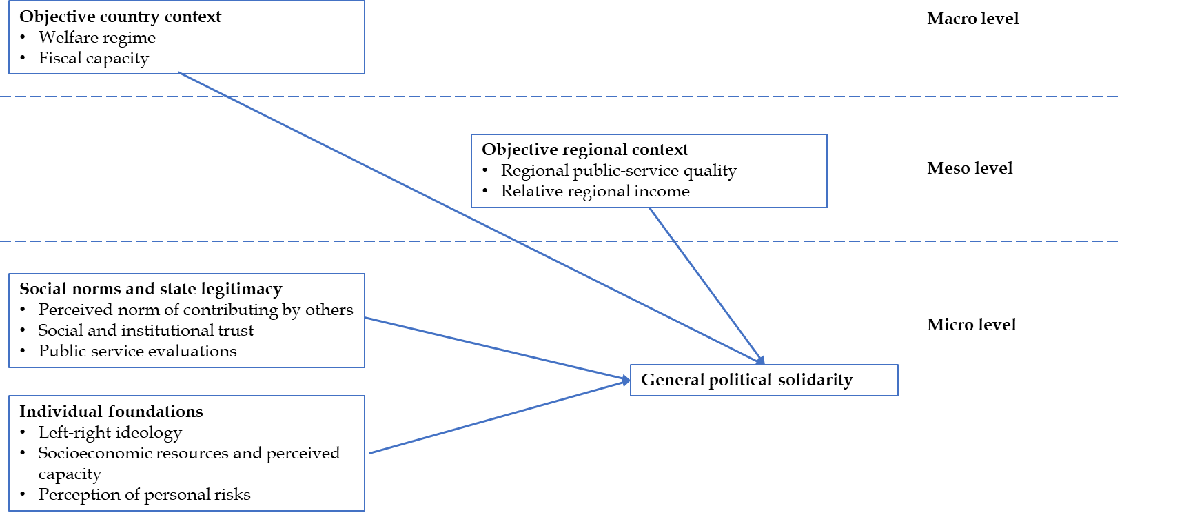
Figure 1: Our causal model of general political solidarity

Micro-Level factors: ideology, resources, norms and state legitimacy

Political ideology and resources
At the micro level, an individual’s own characteristics such as their ideological values, material resources, and personal risks, have a direct bearing on their support for political solidarity. Key micro-level determinants include:
Left-right ideology: early in life, people are socialized into an ideological predisposition and values. This early anchoring has effects on their willingness to act in a politically solidary manner towards others (Goerres and Eicheler 2025). An individual’s ideological leanings strongly influence their stance on welfare and solidarity. Those with left-wing or egalitarian ideologies typically hold values of social equality and collective responsibility, leading them to support expansive welfare programs. In contrast, right-wing or economically conservative individuals emphasize self-reliance, market solutions, and limited government intervention, yielding more skepticism toward redistribution (Feldman and Steenbergen 2001). This pattern is well-documented across democracies: left-identifying citizens consistently express higher support for the welfare state (Roosma, van Oorschot, and Gelissen 2014), whereas conservatives tend to endorse more restrictive notions of solidarity (preferring, for example, that aid be given only to the most “deserving” and favoring lower taxation) (Van Der Waal, De Koster, and Van Oorschot 2013). These ideological differences often persist even when controlling for income or personal benefit.
Socioeconomic resources: In standard models of attitudes towards the welfare state, material self-interest is regularly put forward. People support policies that they benefit from (Baute and Bellani 2025) or expect to benefit from in the future (Enggist, Häusermann, and Pinggera 2022).; and people withdraw support from policies that they only have to pay for but do not benefit from. In this study, we are confronting respondents with the question for support for policies of redistribution that others benefit from. Here are two competing expectations about income. One might argue that richer individuals show more political solidarity because they enjoy the feeling of glow of doing something good for others, a mechanism that is known from studies on philanthropy, or because they want stability in the political system. Or, quite to the contrary, they show less political solidarity because egoism makes them believe that in such a system they are always least likely to benefit.
It is not only objective wealth that matters, but also subjective perceptions of economic security. For example, an individual’s perceived capacity to contribute (do they feel relatively well-off or financially strained?) can modify their support for paying into solidarity programs (Häusermann, Kurer, and Schwander 2016). Someone who is objectively middle-class but feels financially insecure or fears falling behind may be more supportive of welfare viewing it as insurance (Rehm 2011). Subjective social status and feelings of economic anxiety can therefore lead to variations that pure income rank would not predict (Gimpelson and Treisman 2018).
In this study, we deliberately ask people for their support for public redistribution that benefits other people, not themselves. By design, we prime respondents that this is not about public programmes that they can benefit directly. The income and perceived capacity can also be expected to have positive effects. People may want to support such redistribution to give stability to the system - like companies that mainly want a stable system rather than a particular party in power. People with higher incomes also may seek the glow of doing good for others. Many studies of charitable donations (Elis, Mayer, Goerres 2024) actually show that high-income individuals and those who have a positive outlook on their personal income are most willing to donate to others.
People are also not atomised individuals without contacts to others. For instance, in families, people are socially connected to individuals of other age groups (one’s children or parents)
It should be noted that these individual-level factors often interact in complex ways. Ideology can moderate how one’s income influences their attitude (Cavaillé 2023). A wealthy social democrat may still support redistribution strongly, while a poor person with conservative values might oppose some welfare programs despite personally benefiting (Armingeon and Weisstanner 2022). Likewise, personal experience with hardship might soften ideological opposition (e.g., a fiscally conservative person might become more supportive of welfare after experiencing unemployment) (Harrs and Sterba 2023). Put simply, those with higher incomes have more money to give but less reason to rely on welfare, and those with lower incomes have more need but less ability to finance it. This creates a potential conflict between contributors and beneficiaries at the individual level. Many modern welfare states resolve this by instituting universality (so that contributors also benefit) or by fostering normative solidarity (convincing the well-off to support the needy out of moral duty or enlightened self-interest). The net effect on a person’s support for solidarity depends on how they balance self-interest and altruism. Specifically, on how policies affect their own finances against their values and willingness to help others. Political solidarity is highest when these factors align, for example, when a person both needs assistance and ideologically believes in egalitarianism. When they conflict (high need but strong belief in self-reliance, or low need but strong egalitarian conviction) either factor might prevail.

Social norms and state legitimacy
A crucial intervening layer consists of social norms and perceptions of “otherness.” Societies can differ in the informal norms that govern solidarity, essentially, shared expectations about whether fellow citizens merit help and whether others are doing their part. These normative perceptions create a social norm loop that can reinforce or undermine political solidarity (Bicchieri 2009).
One key element is generalized social trust: the belief that most other people are honest and cooperative. High trust serves as a lubricant for solidarity: if people assume others are not trying to cheat the system and would likewise support them in need, they are more willing to pay into collective welfare (Habibov, Cheung, and Auchynnikava 2017; Jensen and Svendsen 2011). When social mistrust is rampant, people “become less likely to feel solidarity with others outside their own in-group”, assuming that “few would voluntarily choose to help them in their hour of need” (Rothstein 2011, 96–98). In such a low-trust climate, citizens doubt that others will reciprocate or that beneficiaries are truly deserving, which leads to withdrawal of support for expansive welfare. This dynamic illustrates how beliefs about others’ contributions condition one’s own. If a person believes that their peers widely support and contribute to solidarity (for instance, that most people honestly pay their taxes and endorse helping the vulnerable), that person is more inclined to do the same, sustaining a high-solidarity equilibrium. On the other hand, if the belief spreads that others are shirking (by not paying taxes, abusing benefits, or opposing welfare) it can trigger a downward spiral of cynicism and diminished support.
Finally, there is also the belief in the state’s capacity to deliver. If citizens are not satisfied with the way the state delivers, they may question whether to be willing to pay into such a system (Levi 1997; Rothstein 2021).

Meso-level factors: Governance quality and regional context
At the meso level, two key contextual factors shape both objective policy outcomes and citizens’ perceptions: (1) the quality of governance (including bureaucratic integrity and effectiveness), and (2) the regional economic context within a country (Charron, Dijkstra, and Lapuente 2013). These factors link national structures to everyday life and shape how people see and practice solidarity.
Quality of governance, measured as the impartiality, efficiency, and fairness of institutions, has a profound impact on political solidarity. When public agencies implement welfare policies competently and fairly, citizens are more willing to finance and support those policies. Empirical studies confirm that “people who perceive public institutions to be fair and efficient are more inclined to support extensive welfare policies and provide resources for them” (Svallfors 2013, p. 364). In a comparative survey of 29 European countries, perceived high-quality government was associated with stronger support for taxes and social spending, even after accounting for other factors (Svallfors 2013). Good governance strengthens the link between egalitarian beliefs and pro-welfare attitudes by assuring citizens that solidarity will be implemented fairly (Kulin 2011). Recent micro-level evidence shows that high-quality government does not simply raise average support for redistribution but structures the income and fairness divide itself: in countries with better government quality, both income and unfairness perceptions become stronger predictors of redistribution preferences (Ahrens 2024). In societies where corruption is low and bureaucratic integrity high, egalitarian-minded individuals are especially likely to demand robust social spending (Rothstein and Uslaner 2005). The logic is intuitive: effective governance assures citizens that their solidarity (e.g. tax contributions) will not be siphoned off by corruption or wasted on inefficiency. According to Bo Rothstein’s theory, trustworthy and impartial institutions create a foundation of social trust, making collective action feasible. By contrast, in poorly governed settings, corruption and arbitrariness corrode that trust. Studies have found that perceptions of corruption can “erode social solidarity,” making citizens less willing to cooperate or help those outside their own in-group (Malmberg 2022).
Regional economic position is another meso-level factor that conditions solidarity, especially in economically diverse countries. Within a nation, regions often differ in prosperity, unemployment levels, and net contribution to the national budget. People in wealthier regions usually see themselves as net contributors to redistribution. Because of that, they may be more skeptical of national solidarity programs that transfer resources to other areas. In contrast, people in poorer regions who tend to benefit from such transfers often show stronger support for redistribution (Beramendi 2007). The territorial structure of inequality influences preferences over fiscal policy centralization (Beramendi 2012). Where inter-regional income gaps are large, people’s support for solidarity can become fragmented along regional lines. Two mechanisms are at play: “differences in the demand for redistribution associated with interregional income differences, and differences in the demand for social insurance associated with the incidence of labor market risks” (Beramendi 2007). Regional inequalities turn objective economic differences into subjective judgments about who deserves help (Gniza and Wrede 2024). For example, a taxpayer in a booming metropolitan region might resent funding welfare programs perceived to mainly assist other regions, unless a sense of national solidarity prevails. On the flip side, a person in a depressed region might perceive national solidarity as a lifeline and view opposition to it as coming from unsympathetic “others” in wealthier areas. Regional context thus shapes whether solidarity is seen as a unifying national project or a zero-sum geographic transfer.
It is important to note that macro and meso factors also influence subjective perceptions of the system’s performance and fairness. Objective indicators like GDP growth, unemployment rate, or inequality level will affect whether individuals feel the country is “doing well” or if the economic system is just. Likewise, governance quality is mirrored in public perceptions of bureaucratic fairness. These perceptions, for example, whether “things are going in the right direction” nationally, or whether officials are honest, feed into support for solidarity policies. Thus, the meso context (quality of government and regional economic standing) both directly affects political solidarity (through actual policy performance and distributive impacts) and indirectly affects it via perceptions of legitimacy and fairness.

Macro-level Factors: Welfare state regimes and fiscal capacity
At the societal macro level, the nature of the welfare state and the state’s fiscal capacity set the stage for political solidarity. Different welfare state regimes embody distinct norms of solidarity. Esping-Andersen’s typology identifies, for example, liberal welfare regimes that offer only modest, means-tested assistance targeted to the poor often with strict, stigmatizing eligibility rules. Such regimes produce a limited institutionalization of solidarity, expecting individuals to rely on the market or direct family for support. In contrast, social democratic regimes pursue universalistic benefits that promote an “equality of high standards” rather than mere minimal needs (Esping-Andersen 1990). These systems treat support as a right, not a product, and spread the costs of caring for dependents across society, showing a broad commitment to mutual help (Korpi & Palme 1998; Rothstein 1998).
In essence, more universal and generous welfare states (as in Scandinavia) institutionalize solidarity as a widely shared norm, whereas minimal welfare states (as in the liberal Anglo-Saxon model) rely more on individual responsibility. This echoes the idea that universal programs generate greater public support by benefiting a wide spectrum of society, whereas means-testing can undermine solidarity through divisions between “givers” and “takers.” (Rothstein 1998).
Fiscal capacity, the state’s ability to raise revenues and fund social programs, enables these regime differences. Wealthier nations with effective tax systems can sustain more extensive welfare provisions. That may foster a culture of solidarity by making redistribution feel affordable and legitimate. By contrast, states with strained budgets face a solidarity dilemma: limited resources force tough choices that can set groups against each other for scarce benefits. Historically, richer and more developed economies have tended to build larger welfare systems, allowing societies to share the financial risks of illness, unemployment, or old age across the whole population instead of leaving individuals to face them alone. This collective pooling of resources makes misfortune more predictable and manageable, strengthening both security and public support for redistribution. In turn, a strong welfare state can reinforce public support by proving effective. As Rothstein (1998) argues in Just Institutions Matter, when people see that social programs reliably deliver social security and reduce poverty, it builds moral trust in the welfare system. Thus, at the macro level, a virtuous cycle can emerge: robust welfare institutions (made possible by fiscal capacity) cultivate public commitment to solidarity, which in turn legitimizes maintaining these institutions through additional taxation. Conversely, where the state’s capacity or commitment to welfare is low, citizens may be less habituated to solidarity in politics.

Integrating across levels: A conceptual model
We test a multi-level framework in which political solidarity is shaped by (A) individual foundations (ideology, resources, perceived capacity, need and risk), (B) social norms and legitimacy (norm perceptions, trust, and public-service evaluations), and (C) objective context at the regional and country level (governance/service quality, economic conditions, welfare institutions, and governance quality).
Hypotheses Bucket A: Individual foundations
H1 Ideology: Individuals who are more economically left-leaning and egalitarian show higher political solidarity than individuals who are more economically right-leaning.
H2 Resources and capacity
H2a Individuals with higher objective socioeconomic resources (income and wealth) show higher political solidarity.
H2b Net of objective resources, individuals who perceive higher personal capacity to contribute (financial security) show higher political solidarity.
H3 Insurance against future needs
H3a Individuals with higher exposure to social risks show higher political solidarity.
H3b Net of objective indicators, individuals who perceive higher personal risk of deterioration and higher future need show higher political solidarity.
Bucket B: Social norms and state legitimacy
H4 Perceived willingness of others to contribute: Individuals who believe that most others contribute fairly (pay taxes, do not abuse benefits, endorse solidarity norms) show higher political solidarity.
H5 Trust and public-service evaluations
H5a Individuals with higher generalized social trust show higher political solidarity.
H5b Individuals with higher institutional trust show higher political solidarity.
H5c Individuals who are more satisfied with the quality and fairness of public services show higher political solidarity.
Bucket C: Objective context
H6 Regional context
H6a Residents of regions with higher public service quality show higher political solidarity.
H6b Holding absolute conditions constant, residents of relatively better-off regions within a country show lower political solidarity on average, consistent with a net-contributor logic in territorial redistribution.
We will also explore macro-level variations among our 7 countries.

Data & Methods

Survey Data Collection
We conducted a cross-national survey in seven European countries in 2026: Croatia, France, Germany, Italy, Poland, Spain and Sweden. The selection of countries was theoretically motivated by welfare regime types and control of corruption, summarised in Table 1. For case selection, we classified the control of corruption indicator from the 2025 World Bank Worldwide Governance Indicators into low, middle and high levels of corruption control using tertiles for European economies.
We obtained ethical approval from the Ethics Review Board of Human-Centered Computing and Cognitive Science at the University of Duisburg-Essen prior to data collection (ID: 2507PWAG7550). Fieldwork took place from 27 February 2026 to 17 April 2026. Response rates among the volunteers on file that were approached by a random selection specific to the country ranged from 29.4 % in Germany to 66.9 % in Spain. In all countries, there are at least 1000 complete interviews (see Appendix A.4.2 for details per country). In Germany, we oversampled respondents from East Germany, and account for this design choice through weighting.
Table 1: Welfare Regime Type and Control of Corruption by Country
Country | Welfare Regime Type | Control of Corruption
Croatia | Post-Communist | Low
Italy | Mediterranean | Middle
Spain | Mediterranean | Middle
Poland | Post-Communist | Middle
France | Conservative | Middle
Germany | Conservative | High
Sweden | Social-Democratic | High
Data Sources. Welfare Regime Type: Own Classification. Control of Corruption: Own classification based on tertiles within European economies of the World Bank Worldwide Governance Indicators, 2025 Update.
Data were collected primarily with Computer-Assisted Web Interviewing (CAWI), with Computer-Assisted Telephone Interviewing (CATI) offered to respondents unable to participate online. The target population was the non-institutionalised adult resident population in each country. Samples were drawn from the IPSOS KnowledgePanel in all countries except for Germany, where the infas Mastersample was used. Both panels recruit participants through random address- and phone-based sampling. This makes self-selection into the panels impossible and ensures that each resident has a known probability of inclusion. From these panels, stratified random samples were drawn by age, gender and education. This high-quality sampling approach allows statistical inference to population statistics, which is impossible without strong modelling assumptions with non-probability samples such as self-recruited opt-in online access panels (Cornesse et al. 2020).
Whenever possible, we used established, validated survey items from large-scale surveys such as the European Social Survey, World Values Survey and International Social Survey Program (see §$ Next iterationfor item sources). We used existing translations where possible. Where not, IPSOS provided translations by native speakers, which were reviewed by a network of country experts￼. The full questionnaire underwent cognitive pretesting (IPSOS, 2025) in late 2025 in the German language version with a diverse sample of eight pretesters. We put special emphasis on the survey items without established translations and survey items we developed ourselves, leading to minor wording adjustments. IPSOS implemented data quality controls in the questionnaire, including response-times to screen out inattentive respondents.
The full dataset contains data from 8,066 completed interviews from Croatia, France, Germany, Italy, Poland, Spain, and Sweden. In the main analyses, we do not use population-size weights. The aim is not to estimate an EU-wide population average, but to compare patterns across the seven country cases and to examine whether similar explanatory mechanisms operate across different institutional and regional settings.

Operationalisation
that the indices are standardized so that effect sizes are directly comparable. Tables A.1 and A.2 in the appendix documents the construction of the main indices used in the analysis of the main survey data. Tables A.3 and A4 give an overview of our strategies to missingness and imputation.

Block | Hypothesis | Predictor | Interpretation
Individual foundations | H1 | Left-right ideology | Higher values indicate a more right-wing position
Individual foundations | H2a | Socioeconomic resources/status | Higher values indicate more income and higher perceived social status
Individual foundations | H2b | Perceived capacity | Higher values indicate greater perceived financial capacity
Individual foundations | H3a | Objective need/risk | Higher values indicate greater benefit receipt or labour-market vulnerability
Individual foundations | H3b | Perceived risk | Higher values indicate greater perceived risk of future hardship
Norms and legitimacy | H4 | Contribution norms | Higher values indicate stronger perceived tax and benefit compliance norms
Norms and legitimacy | H5a | Social trust | Higher values indicate greater generalized trust, fairness, and helpfulness
Norms and legitimacy | H5b | Institutional trust | Higher values indicate greater trust in political and administrative institutions
Norms and legitimacy | H5c | Public-service evaluations | Higher values indicate more positive evaluations of public services
Regional context | H6a | Regional public-service quality | Higher values indicate better regional public-service quality
Regional context | H6b | Relative regional income | Higher values indicate a richer region relative to the national average

Table 1: Overview of preregistered hypotheses
Table 1 summarises the main explanatory variables used in the results section. The full item composition, raw variable names, coding decisions, and deviations from the preregistered measurement plan are reported in Appendix Tables A.1 and A.2.
Most explanatory variables are measured as indices rather than single items. We clean nonresponse, orient all items so that higher values indicate more of the underlying construct, rescale items to a common metric where necessary, and average them within respondents.

Analytical Strategy
The primary tests use unweighted OLS models with country fixed effects and the preregistered respondent-level controls. We estimate the models in blocks that follow the theoretical framework. Block A includes individual foundations: left-right ideology, socioeconomic resources/status, perceived capacity, objective need, perceived risk, and the interaction between perceived risk and capacity. Block B includes social norms and legitimacy: contribution norms, social trust, institutional trust, and public-service evaluations. The full model combines both blocks.
We treat a hypothesis as supported when the estimate in the unweighted full model points in the preregistered direction and the 95% confidence interval excludes zero. Directionally consistent but imprecise estimates are interpreted as mixed evidence. Estimates that are close to zero or point in the opposite direction are interpreted as not supporting the hypothesis. The two regional-context hypotheses, H6a and H6b, are evaluated separately because they rely on contextual rather than individual-level predictors.

Empirical Results
We begin by describing the level and structure of political solidarity across the seven countries. We then test whether the main differences in solidarity are better explained by individual foundations, by perceptions of norms and institutional legitimacy, or by regional context.

Outcome measures and explanatory blocks
Recall that our primary outcome is the general political solidarity index. It measures respondents’ willingness to pay for public redistribution benefiting people in their municipality, their country, and other EU countries.
The models are organized in three blocks. The first block captures individual foundations: left-right ideology, objective socioeconomic resources, perceived financial capacity, objective need, and perceived personal risk. The second block captures social norms and legitimacy: perceived contribution norms, social trust, institutional trust, and evaluations of public services. The third block adds regional context through measures of regional public-service quality and relative regional prosperity within countries.
The expected signs follow the preregistered hypotheses. We expect more left-wing ideology, higher perceived capacity, greater objective need, greater perceived risk, stronger contribution norms, higher trust, and better service evaluations to be associated with higher political solidarity. For objective resources, the expectation is theoretically more specific. Respondents with greater resources may have more capacity to contribute, but they may also be more likely to see themselves as net contributors. However, based on earlier studies, we expect the positive effect of income to prevail.

Cross-national overview and country heterogeneity
We first describe the outcome space before turning to the regression models. Country means showing substantial cross-national variation in political solidarity. Sweden has the highest mean level of general political solidarity (3.7), while Croatia has the lowest (3.0).
Before estimating the pooled models, we also inspect (Figure 3) whether key associations are concentrated in certain national cases. The country-specific estimates are descriptive checks that show whether the relationships between solidarity and three central predictors, ideology, perceived capacity, and public-service evaluations, are broadly similar across countries or driven by one or two cases.
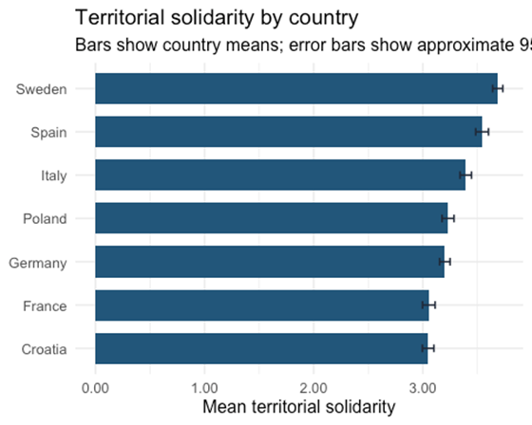
General Political Solidarity by Country
Means of General Political Solidarity
Figure 2. Country means and uncertainty for general political solidarity.
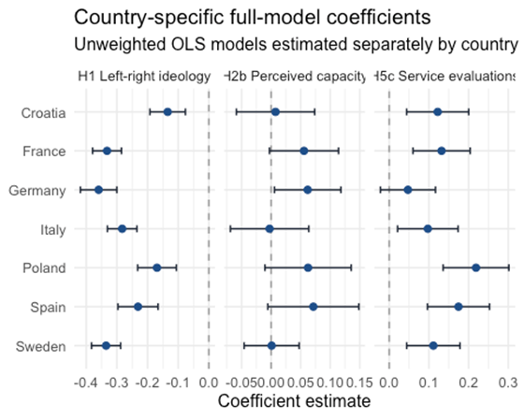
Figure 3. Country-specific estimates for three key predictors from the full model.

A first look at the explanatory patterns
Figure 4 provides a descriptive overview of the preregistered individual-level predictors before we move to multivariable models. For each predictor, respondents are divided into five roughly equal-sized bins. The figure plots the mean value of the predictor in each bin against the mean level of general political solidarity.
Several patterns are already visible in the descriptive evidence. Left-right ideology shows the clearest negative association: respondents further to the right report lower general political solidarity. Perceived financial capacity is positively associated with solidarity, consistent with the idea that people are more willing to support redistribution for others when they feel able to contribute. By contrast, objective need and perceived risk do not show the expected positive descriptive pattern. Objective need is almost flat, while perceived risk is negatively associated with solidarity.
The strongest positive descriptive gradients appear for social trust, institutional trust, and public-service evaluations. Respondents who trust others, trust institutions, and evaluate public services more positively report substantially higher political solidarity. This pattern is consistent with the theoretical claim that solidarity depends not only on individual resources or risks, but also on whether people perceive the social and institutional environment as fair, trustworthy, and effective.
The binned plots are descriptive and do not adjust for country differences or other covariates. They therefore cannot serve as hypothesis tests. They do, however, preview the central empirical question for the regression analysis: whether the strong associations for trust and service evaluations remain once individual foundations and country fixed effects are included, and whether the unexpected descriptive patterns for resources, need, and risk persist in the full models.
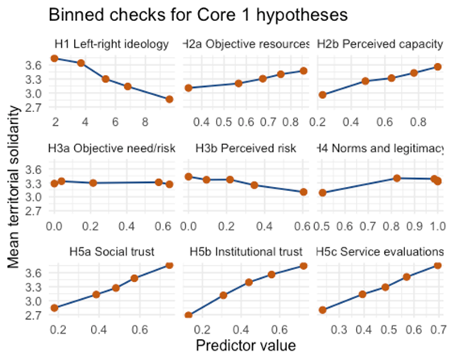
Figure 4. Descriptive associations between preregistered predictors and territorial solidarity. Note: Each panel divides respondents into five approximately equal-sized bins of the focal predictor. Points show bin-level means of territorial solidarity; lines connect these means. The figure is descriptive and does not adjust for country fixed effects or respondent-level controls. Higher values of left-right ideology indicate a more right-wing position; higher values of all other predictors indicate more of the construct named in the panel.

Pooled models: individual foundations and legitimacy perceptions
The pooled regression analysis 8Table 2) turns the descriptive patterns into comparable model-based tests. The full model retains 7,058 respondents, corresponding to 87.5% of the cleaned sample, and explains 34% of the variation in general political solidarity.
Among the individual foundations, left-right ideology is the clearest predictor. More right-wing respondents are substantially less politically solidary than more left-wing respondents (β = -0.266, 95% CI [-0.286, -0.246], p < 0.001). The resource-and-risk results are more mixed. Perceived capacity to contribute remains positively associated with solidarity in the full model (β = 0.036, p = 0.003), and objective need/risk is also positive (β = 0.029, p = 0.008). By contrast, objective resources are close to zero once the attitudinal predictors are included (β = 0.005, p = 0.764), and perceived risk is not statistically distinguishable from zero (β = 0.008, p = 0.455). These results provide strong support for the ideology hypothesis and weaker but still positive evidence for perceived capacity and objective need. They do not support a simple cost-side resource account.
The second block of predictors captures social norms and institutional legitimacy. Here, all estimates are positive and precisely estimated. Social trust (β = 0.158), institutional trust (β = 0.158), and public-service evaluations (β = 0.135) are among the strongest predictors in the full model. Contribution norms also remain positively associated with general political solidarity (β = 0.073, p < 0.001). The pooled models therefore suggest that political solidarity is linked not only to respondents’ ideological position and material circumstances, but also to whether they see other citizens, institutions, and public services as trustworthy, fair, and effective.

 | Block A |  |  | Block B |  |  | Full
Characteristic | Beta | 95% CI | p-value | Beta | 95% CI | p-value | Beta | 95% CI | p-value
H1 Left-right ideology | -0.329 | -0.350, -0.308 | <0.001 |  |  |  | -0.266 | -0.286, -0.246 | <0.001
H2a Objective resources | 0.063 | 0.031, 0.094 | <0.001 |  |  |  | 0.005 | -0.025, 0.034 | 0.764
H2b Perceived capacity | 0.108 | 0.083, 0.133 | <0.001 |  |  |  | 0.036 | 0.012, 0.059 | 0.003
H3a Objective need/risk | 0.054 | 0.030, 0.077 | <0.001 |  |  |  | 0.029 | 0.008, 0.051 | 0.008
H3b Perceived risk | -0.029 | -0.052, -0.006 | 0.012 |  |  |  | 0.008 | -0.013, 0.029 | 0.455
H3 Risk x Capacity interaction | 0.001 | -0.020, 0.022 | 0.930 |  |  |  | -0.004 | -0.023, 0.015 | 0.681
H4 Norms and legitimacy |  |  |  | 0.083 | 0.063, 0.104 | <0.001 | 0.073 | 0.052, 0.094 | <0.001
H5a Social trust |  |  |  | 0.192 | 0.169, 0.215 | <0.001 | 0.158 | 0.135, 0.181 | <0.001
H5b Institutional trust |  |  |  | 0.183 | 0.155, 0.211 | <0.001 | 0.158 | 0.129, 0.187 | <0.001
H5c Service evaluations |  |  |  | 0.150 | 0.122, 0.178 | <0.001 | 0.135 | 0.107, 0.163 | <0.001
Abbreviation: CI = Confidence Interval
Table 2: Regression models of general political solidarity in seven countries with micro-level variables only
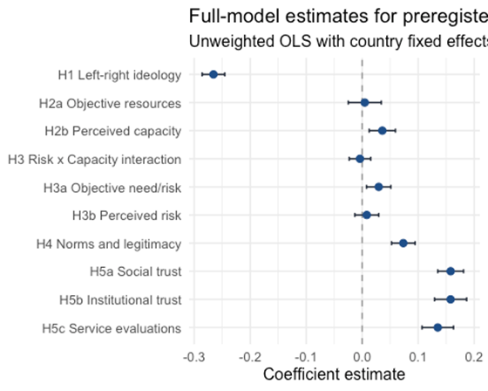
Figure 5: Coefficient plots of full regression model for preregistered predictors of general political solidarity.
Note: Points show standardized OLS coefficient estimates from the full pooled model; horizontal lines show 95% confidence intervals. The model includes country fixed effects and preregistered respondent-level controls. Positive coefficients indicate higher general political solidarity, measured as willingness to pay for redistribution benefiting people at the municipal, national, and EU levels. All predictors are standardized; left-right ideology is coded so that higher values indicate a more right-wing position.
H6 is examined separately because it concerns contextual variation rather than individual-level differences. The regional EQI analysis decomposes public-service quality into two components. The within-country component asks whether respondents living in higher-quality NUTS2 regions are more solidaristic than respondents living in lower-quality regions within the same country. The country-mean component captures cross-national differences in average regional service quality. These models use standard errors clustered by NUTS2 region.
The regional-context results provide little support for H6. Once the full individual-level specification is included, the within-country EQI coefficient is small and statistically insignificant (β = -0.010, 95% CI [-0.046, 0.025], p = 0.571). The country-mean EQI coefficient is positive and statistically significant in the simpler models, but becomes statistically insignificant after trust and service-evaluation measures are added (β = -0.031, p = 0.128 in the full model). Relative regional income is also not robustly associated with general political solidarity (β = 0.014, p = 0.257). Thus, the contextual models do not show that respondents in better-performing or relatively richer regions are systematically more solidaristic once individual-level perceptions and controls are included.
The pattern is nevertheless informative. The positive country-level association between public-service quality and solidarity in the simpler models disappears after adding trust and service evaluations. This suggests that contextual differences in service quality may matter less as direct regional predictors than through citizens’ perceptions of institutional performance, fairness, and reliability.
Table 3. Regional public-service quality and general political solidarity
Model | N | NUTS2 | Within-country EQI estimate [95% CI] | p-value | Country-mean EQI estimate [95% CI] | p-value
Baseline | 7,319 | 124 | -0.026 [-0.065, 0.012] | 0.183 | 0.084 [0.030, 0.139] | 0.003
+ demographics | 7,319 | 124 | -0.022 [-0.060, 0.017] | 0.272 | 0.075 [0.025, 0.126] | 0.003
+ left-right ideology | 6,816 | 123 | 0.005 [-0.029, 0.039] | 0.771 | 0.080 [0.028, 0.131] | 0.003
+ Block A non-ideology | 6,510 | 123 | 0.005 [-0.029, 0.039] | 0.779 | 0.062 [0.014, 0.109] | 0.011
+ trust/service | 6,504 | 123 | -0.010 [-0.045, 0.026] | 0.601 | -0.032 [-0.073, 0.009] | 0.131
Full model | 6,420 | 123 | -0.010 [-0.046, 0.025] | 0.571 | -0.031 [-0.072, 0.009] | 0.128
Note: Entries are standardized OLS coefficients with 95% confidence intervals in brackets. Standard errors are clustered by NUTS2 region. Models use unweighted data. EQI refers to the European Quality of Government Index public-service quality measure.

Binging the micro-, meso and macro levels together: country, region and individual mechanisms
The theoretical framework starts from a simple idea: political solidarity is an individual attitude, but it is formed in broader country and regional contexts. The results therefore have to be read across levels: macro-level country differences, meso-level regional conditions, and micro-level individual mechanisms. This cross-level reading is useful, but it also has an important limit. The country comparison contains seven national cases, or eight if East and West Germany are treated separately. This is enough for a descriptive comparison. It allows us to ask whether the country ordering fits the theoretical expectations about welfare regimes and governance contexts. It is not enough, however, to estimate macro-level effects with credible statistical leverage. This is a known limitation in country-level and multilevel comparative designs with few country units (Bryan and Jenkins 2016). The macro-level comparison in Figure 6 should therefore be read as a descriptive benchmark: it asks whether the country ordering is consistent with welfare-regime theory, not whether welfare regimes have a statistically identified effect on political solidarity.
Read descriptively, the country pattern broadly fits the theory: mean solidarity differs across welfare-state contexts in the expected direction. To group the countries, we draw on the comparative welfare-regime literature: Esping-Andersen’s distinction between social-democratic and conservative welfare regimes provides the classic starting point, while Ferrera’s Southern model and Fenger’s post-communist extension justify treating the Mediterranean and Central-Eastern European cases as distinct regime contexts (Esping-Andersen 1990; Ferrera 1996; Fenger 2007). Mean general political solidarity, measured here by the territorial solidarity index, ranges from 3.05 in Croatia to 3.69 in Sweden. Sweden, the only social-democratic case in the sample, has the highest mean. Spain and Italy, the two Mediterranean cases, also sit relatively high in the country ordering, with an average of 3.47. The conservative and post-communist cases are lower and more mixed: Germany and France average 3.13 across the conservative pair, while Poland and Croatia average 3.14 across the post-communist pair. This pattern should not be read as a formal regime test. With so few cases, welfare institutions cannot be separated from fiscal capacity, corruption control, political histories, and other national differences. Still, it provides a useful baseline for the rest of the results. Political solidarity is not distributed evenly across national settings, and the ordering is broadly consistent with the idea that welfare-state contexts shape how citizens judge redistribution for others.

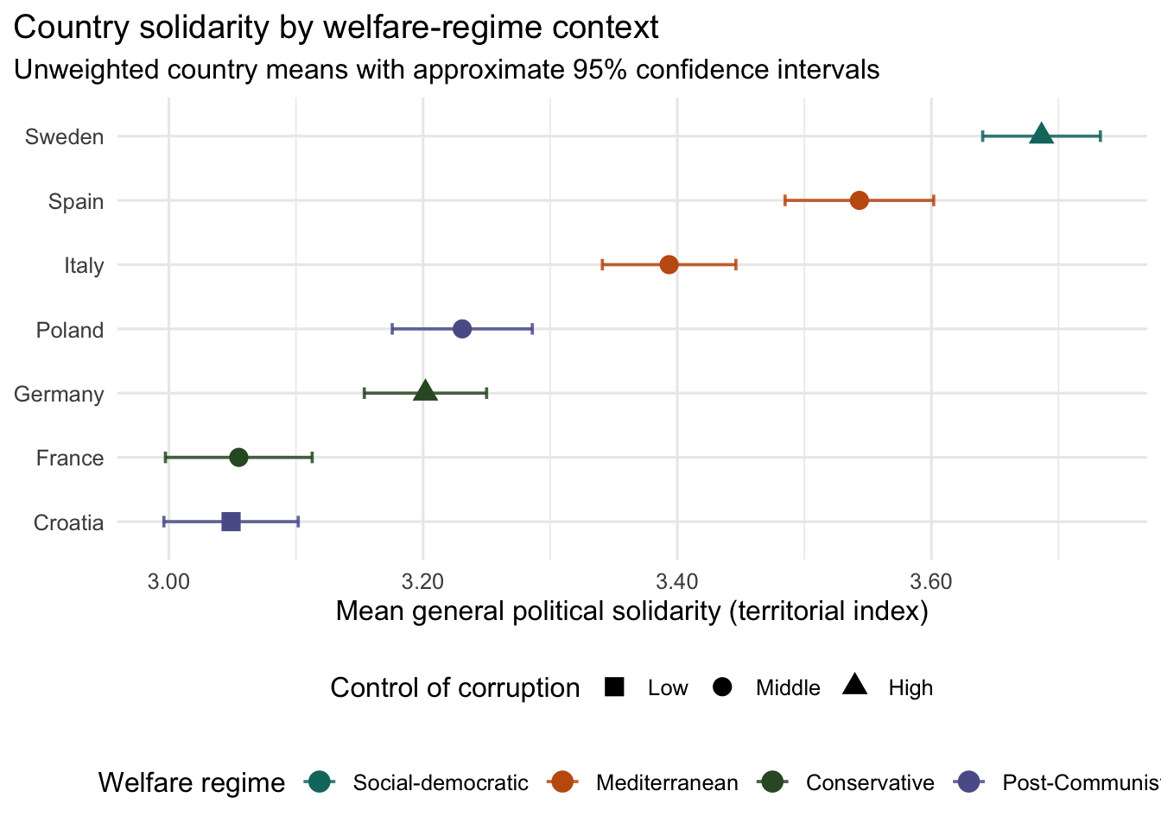Figure 6: Country means for general political solidarity by welfare-regime context.
The plotted measure is the territorial solidarity index. The figure is descriptive and should not be read as a macro-level test of welfare-regime effects.

Table 4 gives the same comparison in more detail. It places the solidarity means alongside welfare-regime classification, corruption control, perceived governance, institutional trust, service evaluations, and the external EQI service-quality indicator. The purpose is not to test regime effects, but to show what kinds of country contexts accompany the observed solidarity levels.

Table 4: Country means and contextual indicators.
Country | Welfare regime | Control of corruption | General political solidarity | Perceived governance | Institutional trust | Service evaluations | Country-mean EQI service quality
Sweden | Social-democratic | High | 3.687 | 0.563 | 0.557 | 0.569 | 1.254
Spain | Mediterranean | Middle | 3.543 | 0.429 | 0.402 | 0.455 | 0.152
Italy | Mediterranean | Middle | 3.394 | 0.424 | 0.428 | 0.419 | -0.704
Poland | Post-Communist | Middle | 3.231 | 0.457 | 0.429 | 0.485 | -0.932
Germany | Conservative | High | 3.202 | 0.496 | 0.489 | 0.502 | 0.786
France | Conservative | Middle | 3.055 | 0.426 | 0.378 | 0.472 | 0.126
Croatia | Post-Communist | Low | 3.049 | 0.370 | 0.318 | 0.421 | -1.287

The meso-level evidence qualifies this baseline. The regional models ask a narrower question. Do respondents living in higher-quality NUTS2 regions, or in regions that are richer relative to their own country, report higher political solidarity once individual predictors and country context are taken into account? The regional indicators draw on the European Quality of Government Index, which captures subnational variation in corruption, impartiality, and public-service quality (Charron, Dijkstra, and Lapuente 2014). The models do not show robust direct regional associations. Both estimates are small and statistically uncertain. The estimate for regional public-service quality is beta = -0.01, 95% CI [-0.046, 0.025], p = 0.571. The estimate for relative regional income is beta = 0.014, 95% CI [-0.01, 0.038], p = 0.257. These estimates do not mean that regional context is irrelevant. Rather, they suggest that the available regional indicators do not explain much additional variation once individual attitudes, legitimacy beliefs, social norms, and controls are included. One plausible interpretation is that regional and country contexts matter partly by shaping the perceptions through which citizens judge redistribution, institutions, and other citizens (Svallfors 2013). A second, more methodological possibility is that the linked regional indicators are too coarse, or the within-country variation too noisy, to detect direct regional differences in this design.
The clearest empirical pattern appears at the individual level. In the full model, solidarity is most consistently associated with ideology, social trust, institutional trust, service evaluations, contribution norms, perceived capacity, and need or risk. This should not be read as a purely individual-level explanation. Instead, it clarifies where the present data have the most leverage. Country contexts provide different descriptive baselines, and regional context remains theoretically relevant, but the strongest survey evidence points to the perceptions and orientations through which citizens evaluate the solidarity system. In substantive terms, citizens are more willing to support redistribution for others when the social and institutional environment appears credible: when others are expected to contribute, institutions are trusted, and public services are seen as fair and effective.
Figure 7 summarizes this interpretation across the three levels. The macro layer refers to country context, the meso layer to regional context, and the micro layer to individual attitudes, social norms, and perceptions of state legitimacy. The overall conclusion is cautious but still substantive: political solidarity is shaped by institutional contexts, but in these data it is most clearly observed through individual trust, perceived legitimacy, and evaluations of system performance.

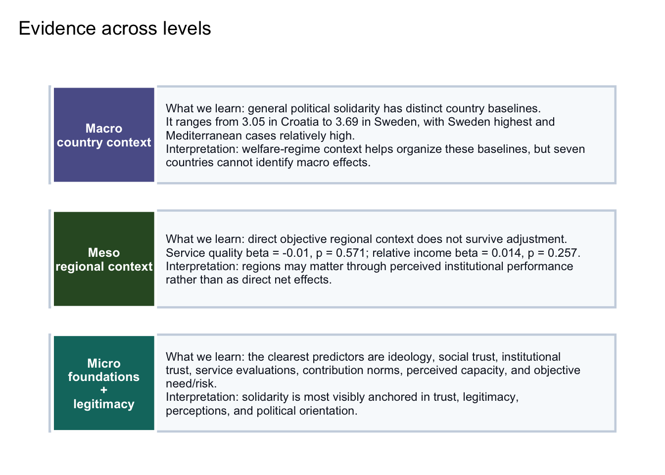Figure 7: Summary of the evidence across macro, meso, and micro levels.

Our Contributions
We asked what drives citizens’ willingness to support costly public redistribution for others. The results point to a relatively clear pattern. Political solidarity in this seven-country sample is strongly structured by ideology and by perceptions of trust, institutional legitimacy, and public-service performance. By contrast, objective resources, need, and regional position matter less consistently than whether respondents see other people, institutions, and public services as trustworthy and fair.
The strongest individual-level divide is ideological. Respondents on the right are less politically solidary and draw a sharper distinction between conventionally deserving groups and migrants. This is not surprising, but it is substantively important. Political solidarity is not merely a response to one’s own economic position or exposure to risk. It is also embedded in broader political orientations about redistribution, deservingness, and the proper scope of collective responsibility.
At the same time, the material foundations of solidarity are more complicated than a simple net-contributor model would suggest. We do not find strong evidence that respondents with greater socioeconomic resources are consistently less solidaristic once attitudes and perceptions are taken into account. Perceived capacity to contribute is positively associated with solidarity, and objective need or risk also shows some positive association. This suggests that solidarity may be strongest not simply among those who expect to benefit, nor simply among those who can afford to pay, but among respondents who combine a sense of capacity with a sense that collective protection is meaningful.
The clearest substantive pattern concerns trust and legitimacy. Respondents who trust other people, trust institutions, and evaluate public services positively are more willing to support redistribution for others. This supports the central argument of the paper: political solidarity depends not only on distributive position, but also on whether citizens believe that the solidarity system works. People appear more willing to support collective redistribution when they think others contribute fairly, institutions are reliable, and public services deliver. In this sense, solidarity is not only a moral preference or a material calculation. It is also a judgement about the credibility of the system through which redistribution is organised.
The regional-context results qualify this argument. We do not find robust direct associations between regional public-service quality, relative regional income, and general political solidary once individual-level perceptions are included. One interpretation is that context matters mainly through citizens’ perceptions: better-performing institutions may shape solidarity by building trust and improving evaluations of public services. Another interpretation is more cautious: the available regional indicators may be too coarse, or the within-country variation too limited, to detect direct contextual effects in this design. The present analysis therefore supports the importance of perceived institutional performance more clearly than it supports a direct regional-context effect.
Several limitations should be kept in mind. The analysis is cross-sectional, so the estimates should be interpreted as associations rather than causal effects. Trust, service evaluations, and solidarity may partly reflect common underlying dispositions, and the direction of causality cannot be established here. Some preregistered measures were only partially available in the final survey file, which narrows the empirical coverage of the corresponding hypotheses. Finally, although the survey allows comparison across seven country cases, it does not cover all welfare-regime types or all forms of European regional inequality.
Despite these limitations, the results suggest a clear implication. Political solidarity is unlikely to be sustained by material interest alone. Citizens’ willingness to support redistribution for others appears to depend heavily on whether they regard the social and institutional environment as trustworthy, fair, and effective. In contemporary Europe, where welfare states face demographic, fiscal, and political pressure, maintaining solidarity may therefore require more than persuading citizens about need. It may also require preserving confidence that institutions can organise redistribution fairly and that others are contributing as well.

Appendix
Table A.1: Operationalisation of concepts
Micro level: questionnaire-based operationalisation
Bucket | Concept | Questionnaire items (IDs and brief wording) | Suggested operationalisation (variables, coding, notes)
Outcome | Political solidarity (willingness to support welfare for others) | plsol1: Willingness to pay for public redistribution  Rows: my village, town or city.; {Country}.; other EU countries who do not live in {Country}.  plsol2: Willingness to pay for target groups  Rows: children.; older people.; the poor.; people from other EU countries who live in [country].; people from countries outside the EU who live in [country].  scgv: Governmental Scope: Standard of Living  Rows: older people?; children?; the poor?; people from other EU countries who live in [country]?; people from countries outside the EU who live in [country]?  plsolfund: Preferred payment for public redistribution | Primary DV from willingness-to-pay/support statements.  Build: general political solidarity, (  Variables: sol_territ_index (mean plsol1); sol_group_overall (mean plsol2);  sol_group_deserving (children/older/poor); sol_group_migrants (EU-in-country, nonEU-in-country);  welfare_chauvinism = deserving minus migrants.  Responsibility analogues: resp_* from scgv.  plsolfund is conditional.  Interacting plsol1 & pslos2?
A. Individual foundations (H1) | Economic ideology and egalitarian values | leftright: Left-right self-placement  pol: Political orientation  Rows: a. The government should take measures to reduce differences in income levels.; b. The less the government intervenes in the economy, the better it is for [country].; c. Gay men and lesbians should be free to live their own lives as they wish.; d. A woman should be prepared to cut down on her paid work for the sake of her family.  taxwelf: Trade-off: Tax and welfare state  soligame: Solidarity game | Use left-right self-placement plus the political orientation grid.  Keep economic and cultural dimensions separate.  Variables: econ_left_index from pol rows a and b plus taxwelf (align direction so higher = more pro-redistribution);  left_right = leftright; solidarity_behavior = soligame (0 to 100).
A. Individual foundations (H2) | Objective resources (income) and subjective status | hincome: Household income  hhsize: Household size  hincshare: Share of household income  slfstatus: Self-placement: status ladder | Probably: Equivalize income by household size.  Variables: income_equiv = income_decile / sqrt(hhsize); subjective_status = slfstatus.
A. Individual foundations (H2, ambiguous, see comments at the end of hypotheses section) | Education | eduyrs: Education years | Education can lower solidarity if it proxies income and insider position,  but can raise solidarity via universalist values, trust, and broader identities.  Treat sign as empirical. Variable: education_years = eduyrs (test linear and threshold forms).
A. Individual foundations (H2/H3, ambiguous) | Labour market position and occupational status proxy | EmploymentStatusKP: Economic activity: type econhour: Economic activity: hours of paid work | Instrument measures labour force status (not occupational prestige).  Use as proxy for status and risk exposure;  Variables: employed, unemployed (active/passive), outside labour force (retired, disabled, care), work_hours (if employed).
A. Individual foundations (H3) | Objective need and benefit receipt | pubpay: Receiving public payments  Rows: 1 Retirement pension; 2 Child, family or care allowance/benefit; 3 Unemployment benefit; 4 Disability benefit/pension; 5 Housing, rent or heating benefit; 6 Social assistance or minimum income benefit | Use benefit receipt as objective need/exposure.  Variables: benefit_any; benefit_count; benefit_type dummies (pension, child/care, unemployment, disability, social assistance, housing).
A. Individual foundations (H3) | Perceived personal risk and future need | prsk: Personal risk assessment  Rows: 1 not have enough money for everyday goods in your household?; 2 be out of work and be looking for new work for at least 4 weeks?; 3 be unfit for work or your usual daily activities for at least 4 weeks?; 4 have less time for your job or your usual daily activities than you would wish because you have to take care of a family member or relative? | Perceived likelihood of adverse events in next 6 months.  Variables: risk_index; risk_econ (money + unemployment); risk_health_care (health limitation + care obligation).
A. Individual foundations (H2b/H3c) | Perceived household economy and financial resilience | eco: Current economic assessment: national economy  Rows: The situation of the [country adjective] economy; The financial situation of your household;  fresil: Financial resilience | Perceived capacity and scarcity.  Use for heterogeneity tests of the alternative mechanism where acute strain may reduce solidarity.  Variables: econ_eval_household (eco household item); financial_resilience = fresil.
B. Social norms and legitimacy (H4) | Perceived willingness of others to contribute and norm climate | rednrmdsc: Redistribution norm: descriptive [  rednrminj: Redistribution norm: injuctive [  sochelp: Helping norm: descriptive norm: Subjective social norm [Rows: Cheating on tax if someone has the chance; Claiming state benefits which someone is not entitled to | Combine descriptive and injunctive norms plus tolerance of cheating (tax and benefit abuse).  Variables: norms_prosolidarity = mean(rednrmdsc, rednrminj, sochelp);  cheating_tolerance = mean(norm items, reverse so higher means stronger norm compliance).
B. Social norms and legitimacy (H5a) | Generalised social trust and fairness expectations | soctrst: social trust and helping norm: injuctive  percfair: Perceived fairness  perchelp: Perceived helpfulness | Variable: social_trust_index = mean(soctrst, percfair, perchelp).
B. Social norms and legitimacy (H5b) | Institutional trust and democratic satisfaction | trst: Political trust Rows: [country]’s parliament?; the armed forces?; the legal system?; politicians?; political parties?; public authorities in your village, town or city?; ...  satdem: Satisfaction with democracy | Variables: inst_trust_index = mean(trst items); satisfaction_democracy = satdem.
B. Social norms and legitimacy (H5c) | Public service satisfaction and perceived relative performance | pssatgen: Public service: overall satisfaction  pssatloc: Public service: relative satisfaction in local area | Variables: service_satisfaction = pssatgen; service_relative_local = pssatloc.
B. Social norms and legitimacy (H5c, mechanism) | Perceived public service quality across domains | psq: Quality public sector  Rows: Public health care; Schools; Tax authority; e. Public transport; Benefits and employment services; Public administration in my village, town or city | Variables: ps_quality_index = mean(psq rows);  optional domain sub-indices (social: healthcare + schools; administrative: tax + benefits + local admin; transport separate).
B. Social norms and legitimacy (H5c, mechanism) | Experience-based fairness and efficiency of services | pse: Public service Rows: When I use public services in [country], I am treated fairly and with respect.; Public services in [country] use resources efficiently and are well-run.; If I need help from a public service in [country], I can expect to receive it promptly.; Public officials in [country] act in the public interest, and do not abuse their position for personal gain. | Variable: ps_process_index = mean(pse items).
C. Boundaries of solidarity | Deservingness criteria and conditional solidarity | dsvr: Deservingness  Rows: People who are poor because of bad choices they made should be denied social benefits and services.; People who receive social benefits and services should be content instead of complaining.; It is not fair that people receive social benefits or services to which they have not contributed.; When granting social benefits and services, people like me should get more priority.; Social benefits and services should only be available to those who truly live in poverty. | Variable: deservingness_restrictive (code so higher means more restrictive).  Use to explain group-specific solidarity and welfare chauvinism.
C. Boundaries of solidarity | Immigration attitudes and correlates of welfare chauvinism | immiforc: Immigration: forced migrants  immiecon: Immigration: economic migrants  immicullife: Cultural Life enriched by immigration | Variable: immigration_openness = combined index after aligning direction (higher means more positive).
C. Boundaries of solidarity | Identity and in-group proximity; migration background | id: Identification  Rows: 1 your village, town or city?; 2 {COUNTRY}?; 3 the European Union?; 4 the world as a whole?  idminor: Self-identification: minority group [  citiz: Citizenship  borncntry: Born in country  yrinccntry: Year first living in country  bornfath: Father born in country  bornmoth: Mother born in country | Variables: id_local/id_national/id_EU/id_world from id rows.  Migration background dummies from borncntry/bornfath/bornmoth; minority_self_id from idminor.
C. Boundaries of solidarity | Social networks and contact (ethnic, political, class, age) | frndinch: Friends networks: rich  frndincl: Friends networks: poor  frndethn: Friends network: ethnicity  frndpol: Friends network: other politics  frndoldr: Friends networks: 10 years older  frndyngr: Friends networks: 10 years younger | Use as moderators of otherness and norms.  Variables: contact_ethnic, contact_political, contact_class, contact_age.
Additional mechanism | Perceived tax burden and fairness of contributions | txbrd: Current Tax Assessment  Rows: For those with high incomes among the highest-earning quarter of people, taxes are …; For those with middle incomes, taxes are …; For those with low incomes among the lowest-earning quarter of people, taxes are … | Variables: perceived_progressivity (contrast high vs low) and tax_burden_index.
Controls | Political engagement, wellbeing, household composition, contextual perceptions | polint: Political interest  poldisfam: Political discussions: family and friends  poldiscol: Political discussions: work colleagues  votetrnt: Recalled turnout national parliamentary election  voteprspopen: Prospective vote choice: country of interview [Single Answer & Open End]  lifesat: Life satisfaction  lnly: Loneliness  Rows: 1 you lack companionship?; 2 left out?; 3 isolated from others?  partner: Partnership  livtogr: Living Together  Hhchldu18: Household number children aged <18  crisoc: Crisis perception of country's society  euintgr: European integration attitude  Age: age  Gndr: gender | Use as controls and for robustness/heterogeneity tests.  Discussion_frequency = mean(poldisfam, poldiscol).  Loneliness_index = mean(lnly rows).  Perceived societal crisis (crisoc) can help probe the strain mechanism.

Table A. 2: Meso and macro level: external indicators (linked to micro perceptions)
Level | Concept | External indicator (outside questionnaire) | Linked micro perception/mediator
Region (meso) | Quality of governance (impartiality, quality, low corruption) | QoG EU Regional Dataset (NUTS2) pillars or aggregate; optional national WGI equivalents for robustness. | pse, psq, pssatgen, trst
Region (meso) | Regional prosperity and fiscal capacity | Regional GDP per capita (PPS) and fiscal capacity proxies; OR Regional government revenue per capita; OR purchasing power standards per capita | eco, fresil, txbrd
Region (meso) | Regional unemployment and labour market risk | Regional unemployment rate; | prsk, EmploymentStatusKP
Region (meso) | Relative regional position within country | Rank or z-score of regional indicators within country; or: deviation from national GDPpC | pssatloc, id
Country (macro) | Welfare state universalism and regime type | Regime typologies or quantitative universalism measures. | Cross-level interactions with income and risk; taxwelf as attitudinal context
Country (macro) | Fiscal capacity | Government revenue per capita or revenue-to-GDP (Eurostat/OECD). | eco, txbrd; fresil and slfstatus
Country (macro) | Inter-regional inequality | Variance of regional GDP per capita and unemployment within country (ratio or Gini). | pssatloc; welfare chauvinism contrasts

A.4 Imputation Summary
Income is the only variable with substantial missingness. Overall, 902 income values are imputed, corresponding to 11.2% of the sample. Other variables have minor missingness and are imputed using simple country-level mean or mode rules.
Table A.3: Country-level summary of income imputation.
country | Observed income | Regression imputed | Country-mean fallback | Total imputed
Croatia | 88.9 | 0.0 | 11.1 | 11.1
France | 90.9 | 4.0 | 5.1 | 9.1
Germany | 88.6 | 4.7 | 6.8 | 11.4
Italy | 85.9 | 5.0 | 9.0 | 14.1
Poland | 85.8 | 5.6 | 8.7 | 14.2
Spain | 88.8 | 4.6 | 6.6 | 11.2
Sweden | 93.0 | 2.9 | 4.2 | 7.0
4.5 Missingness And Retention
Table A.4 Missingness in the variables used in the main model.
variable | meaning | n_total | n_missing | pct_missing
left_right_ideology | Left-right self-placement, where lower values are left and higher values are right | 8066 | 576 | 7.1
perceived_risk_index | Perceived risk of future need or deterioration index | 8066 | 346 | 4.3
norms_legitimacy_index | Norms and perceived contribution index; partial Hauptfeld version uses tax morale and welfare fraud norms | 8066 | 181 | 2.2
perceived_capacity_index | Perceived personal capacity to contribute index | 8066 | 94 | 1.2
institutional_trust_index | Institutional trust index; partial Hauptfeld version excludes politicians and parties | 8066 | 36 | 0.4
objective_need_index | Objective exposure to social need/risk index | 8066 | 8 | 0.1
solidarity_territorial | Territorial solidarity index: willingness to pay for redistribution at municipal, country, and EU levels | 8066 | 0 | 0.0
objective_resources_index | Objective socioeconomic resources index | 8066 | 0 | 0.0
social_trust_index | Generalized social trust index | 8066 | 0 | 0.0
service_quality_index | Public-service satisfaction, quality, fairness, efficiency, helpfulness, and integrity index | 8066 | 0 | 0.0
income_equiv | Household income equivalized by square-root household size | 8066 | 0 | 0.0
age | Respondent age | 8066 | 0 | 0.0
gender_binary | Gender indicator: 0 male, 1 female | 8066 | 0 | 0.0
education_level | Highest education level | 8066 | 0 | 0.0
migrant_background | Respondent born outside country of interview | 8066 | 0 | 0.0
hincome_imputed | Indicator for household income deciles imputed by country-specific regression or fallback mean | 8066 | 0 | 0.0
The unweighted full model retains 7058 of 8066 respondents after listwise deletion (87.5%).

